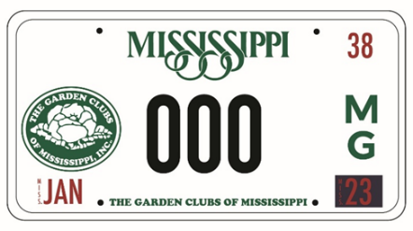
THE GARDEN CLUBS OF MISSISSIPPI
Official Car License Plate

ORDER YOURS TODAY!

Support GCM and proudly display The Garden Clubs of Mississippi name and logo on your car tag to let others know about our great organization. You not only will be helping to get our name out for all to see around the state, but a portion of the specialty license fee is returned to the GCM. This is a fund-raising opportunity we all can participate in to further advance our organization.

A minimum of 300 applications and fees must be collected before the tag goes into production. We anticipate the tag will be produced in 2023. Please consider placing your order for a GCM tag and send your application and check today.

Once the tag has been produced, you will be notified. You will then go to your County Courthouse to pick up your GCM license plate. When your car tag renewal is due each year, you may continue to pay the $33.00 annual fee for the specialty license plate to retain your GCM license plate.

LICENSE PLATE ORDER FORM
Mail this form with your check to: | Melinda Causey  4621 Oak Hill Road  Meridian MS 39503
Make check payable to: | The Garden Clubs of Mississippi, Inc.
Car registration name and information:
First Name: | Last Name:
Mailing Address:
City | Zip
Phone: | Email:
County for car tag registration:
Current license plate number:

